**EE XXX: Electromagnetic Interference and Compatibility- part-1**

**Contents**

1. **Understanding Electromagnetic Interference?**
   1. Propagation of EM waves and transmission lines
   2. Electrostatic and electro-dynamic Induction
   3. Coupling mechanism of EM energy
   4. Performance lacunae in non-EMC compliant systems.
   5. Classification of Electromagnetic Interference
   6. Rationale behind the EMI/EMC standards and compliance tests
2. **Quantification of the EMI and Specifications in EMC standards**
   1. Units-definitions and usage
   2. Frequency bands and measurement environment in EMI/EMC standards

2.2.1: General description of EMC tests:

2.2.2: EMI measurement instruments

2.2.3: EMI generating instruments

* 1. Tests for conducted EMI and EMC
  2. Tests for Radiated EMI and EMC

1. **Designing for the compliance to CE and CS**
   1. Generating mechanism of conducted emissions
   2. Quantification conducted EMI
   3. Techniques to reduce conducted emissions
   4. Source of conducted EMI and susceptibility requirements
   5. Techniques to reduce conducted susceptibility
   6. Numerical Problems
2. **Designing for the Compliance to RE and RS**
   1. Generating mechanism of radiated emissions
   2. Quantification radiated EMI
   3. Techniques to reduce radiated emissions
   4. Source of radiated EMI and susceptibility requirements
   5. Techniques to reduce radiated susceptibility
   6. Numerical Problems
3. **Grounding and Shielding**
   1. Significance of the earth-ground: faults and protection
   2. Equi-potential plane and grounding
   3. Signal return
   4. Numerical problems
4. **Intra System EMC compliance**
   1. EMI between different subsystems
   2. EMI on the printed circuit board (PCB)
   3. Mathematical modelling of EMI on PCBs
   4. Miscellaneous EMI mitigating techniques on
   5. Numerical problems
5. **Biological Effects of Electromagnetic radiation** 
   1. Ionizing and Non-ionizing Radiation
   2. Units of radiation measurement
   3. Safety standards for non-ionizing radiation
   4. Relating SAR to the exposure fields
   5. Numerical problems

**References Material**

1. David Watson, “Electromagnetic Compatibility: Methods, Analysis Circuits and Measurements” CRC press, 3rd Ed. 2016.
2. V Prasad Kodali, “Engineering Electromagnetic Compatibility”, IEEE Press, Newyork, 2001.
3. Henry W. Ott, “Electromagnetic Compatibility Engineering”, John Wiley & Sons Inc, Newyork, 2009
4. Daryl Gerke and William Kimmel, “EDN‟s Designer‟s Guide to Electromagnetic Compatibility”, Elsevier Science & Technology Books, 2002
5. W Scott Bennett, “Control and Measurement of Unintentional Electromagnetic Radiation”, John Wiley & Sons Inc., (Wiley Interscience Series) 1997.
6. Dr Kenneth L Kaiser, “The Electromagnetic Compatibility Handbook”, CRC Press 2005,
7. Clayton R. Paul, “Introduction to Electromagnetic Compatibility”, 2nd ed., Wiley (2010) ISBN-10: 9788126528752 ISBN-13: 978-8126528752.
8. David K. Cheng, “Field and Wave Electromagnetics” 2nd ed. Pearson Education, (2009).
9. William G Duff, “Designing Electronics Systems for EMC”, SciTech Publishing (15th May 2011)ISBN-10: 1891121421, ISBN-13: 978-1891121425
10. MIL-STD-461 G, “REQUIREMENTS FOR THE CONTROL OF ELECTROMAGNETIC INTERFERENCE CHARACTERISTICS OF SUBSYSTEMS AND EQUIPMENT AMSC” Department of Defense, USA. (Draft released on 2nd March 2015)

**Course Syllabus:**

**BASIC THEORY**

Introduction to **Course** EMI and EMC, Intra and inter system EMI, Elements of Interference, Sources and Victims of EMI, Conducted and Radiated EMI emission and susceptibility, Case Histories, Radiation hazards to humans, Various issues of EMC, EMC Testing categories, EMC Engineering Application.

**COUPLING MECHANISM**

Electromagnetic field sources and Coupling paths, Coupling via the supply network, Common mode coupling, Differential mode coupling, Impedance coupling, Inductive and Capacitive coupling, Radiative coupling, Ground loop coupling, Cable related emissions and coupling, Transient sources, Automotive transients. Categorization of the electromagnetic interference: emission, susceptibility, transients, crosstalk, shielding and compatibility, signal integrity.

**EMI MITIGATION TECHNIQUES**

Working principle of Shielding and Murphy‟s Law, LF Magnetic shielding, Apertures and shielding effectiveness, Choice of Materials for H, E, and free space fields, Gasketting and sealing, PCB Level shielding, Principle of Grounding, Isolated grounds, Grounding strategies for Large systems, Grounding for mixed signal systems, Filter types and operation, Surge protection devices, Transient protection.

**STANDARDS AND REGULATION**

Need for Standards, Generic/General Standards for Residential and Industrial environment, Basic Standards, Product Standards, National and International EMI Standardizing Organizations; IEC, ANSI, FCC, AS/NZS, CISPR, BSI, CENELEC, ACEC. Electro Magnetic Emission and susceptibility standards and specifications, MIL461E Standards.

Test Set-ups, units (e.g. dBμVm-1Hz-1), Antenna facture etc.

**EMI TEST METHODS AND INSTRUMENTATION**

Fundamental considerations, EMI Shielding effectiveness tests, Open field test, TEM cell for immunity test, Shielded chamber , Shielded anechoic chamber, EMI test receivers, Spectrum analyzer, EMI test wave simulators, EMI coupling networks, Line impedance stabilization networks, Feed through capacitors, Antennas, Current probes, MIL -STD test methods, Civilian STD test methods.

**BASICS OF BIOLOGICAL EFFECTS OF EM WAVES**

Mechanism of interaction of EM waves with live tissue, Ionizing and non-ionizing radiation And their effects, Measurement techniques of EM radiation.

**List of Symbols and Abbreviations**

**Symbols**

**ε :** Permittivity

**θ :** Angle of elevation, angle

λ : Wavelength

**μ :** Permeability

**ν** : Frequency (especially in the context of photon energy)

**ɸ :** Azimuth angle

σ : Target Cross section

**τ :** Pulse width

**ω :** Angular frequency

**c** : Velocity of electromagnetic waves

**Abbreviations**

**AF :** Antenna Factor

**DUT** : Device under Test (Some literature refers it as times called **EUT**: Equipment under test)

**EM :** Electromagnetic(waves, energy, radiation)

**EMI**  : Electromagnetic interference

**EMC** : Electromagnetic Compatibility

**EMICP :** Electromagnetic Interference Control Procedure

**EMITP :** Electromagnetic Interference Test Procedure

**EMP :** Electromagnetic Pulse

**ERP :** Effective Radiated Power

**ESD :** Electrostatic Discharge

**IF** : Intermediate Frequency

**FFT** : Fast Fourier Transform

**FM** : Frequency modulation

**MoSFET :** Metal Oxide semiconductor Field Effect Transistor

**IGBT** : Insulated gate bipolar transistor.

**NF, *Fn* :** Noise Figure

**PCB**  : Printed Circuit board(s); they are also referred as ‘printed wiring boards’

**RBW** : Resolution bandwidth

**RF** : Radio Frequency

**RMS** : Root Mean Squared

**SNR** : Signal to Noise Ratio

**Chapter-1**

**Understanding Electromagnetic Interference**

Electromagnetic field is a natural phenomenon and electromagnetic waves are present everywhere. We are aware that earth has its own magnetic field. Atmospheric phenomena like lightning create large electric and magnetic field impulses. The effects of Sun’s electromagnetic storm are felt on the earth. In other words, EM fields are present everywhere!

The propagation of electromagnetic (EM) waves can be simplistically described by the diagram shown in Fig. 1.1. The cross product ***E*** *X* ***H*** vector, whose direction is given by the ‘right Hand Rule’ is called the Poyinting vector and gives the direction of the energy flow. If two EM waves of equal magnitude travelling in opposite directions interfere, it forms a standing wave. Such situation is observed when an EM wave is incident on a perfect conductor. Fig 1.2 presents a schematic of the situation.

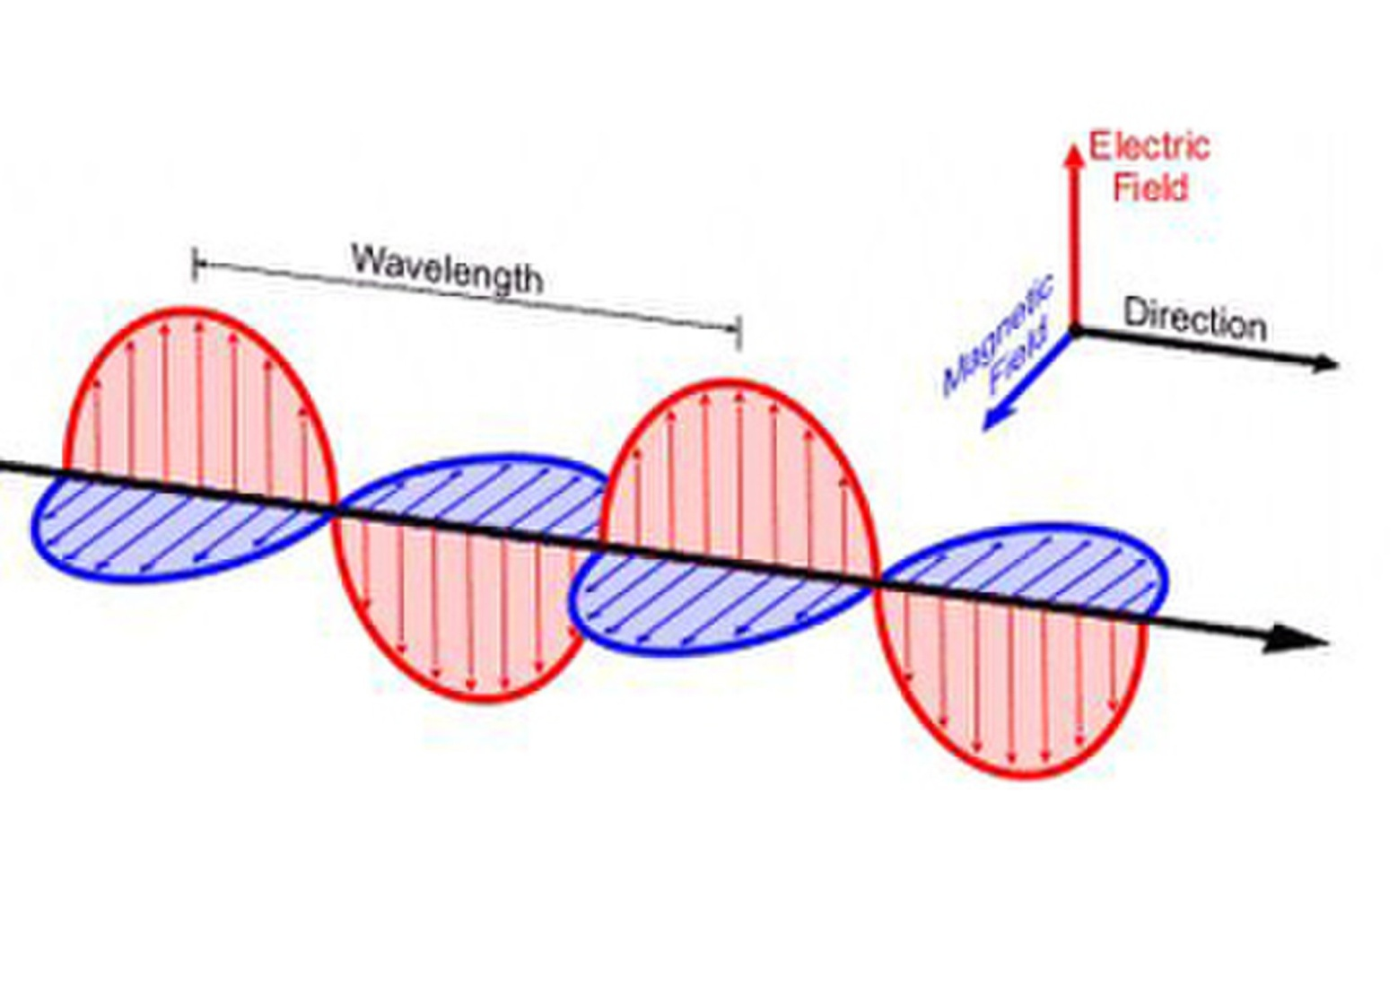 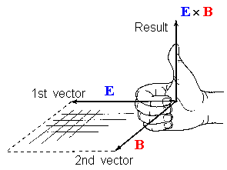

***E***X***H***🡺

Poyinting vector

**Fig.1.1 Schematic of travelling EM wave**

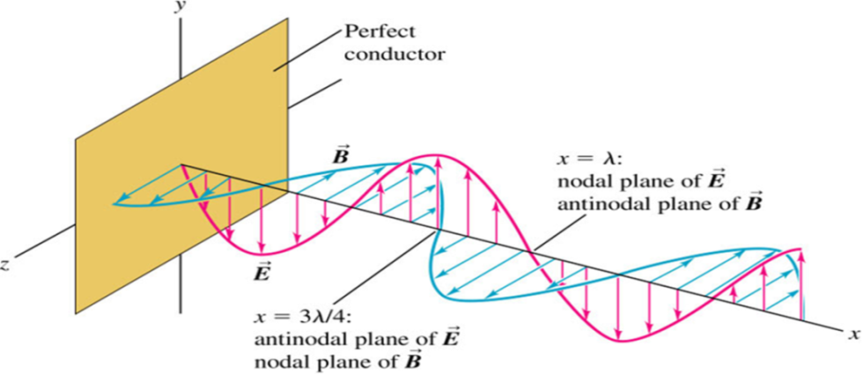

**Fig.1. 2 Schematic of standing EM wave**

Reflection of EM waves is the simplest example of ‘electromagnetic interference’. The reflected wave interacts with the forward wave and forms a ‘standing wave’🡺 stops the propagation of energy! Similarly, EM waves from other sources may also disturb the propagation of EM wave. With this visualization, we come-up with an informal and simplistic definition of the Electro-magnetic Interference (EMI) as follows:

If presence of any EM energy disturbs the electromagnetic field pattern of any equipment or system; it is called ‘electromagnetic interference (EMI)’.

In the similar manner we can have a definition of electromagnetic compatibility as follows:

If any equipment performs its function continuously in the ‘intended operation environment’, the equipment is said to be ‘electromagnetically compatible’ or ‘electromagnetically compliant’. In other words, Electromagnetic compatibility (EMC) is a property of an equipment to function in its normal operating environment in presence of different EM energy waves. This also means that performance of the equipment does not affect by the disturbances caused by the EM-waves present.

It is desirable to have ‘electromagnetically compliant’ equipment. Such systems need to be ‘designed’ to function in environment(s) contaminated by the electromagnetic waves. This is possible if we understand the coupling mechanisms of EM wave and quantify the amount of coupling energy and the extent of which can it disturb the signals in the system. These lecture notes will attempt to present the computations with suitable illustrations.

Fig 1.3 shows the electromagnetic wave spectrum and its usage for various applications. It is seen that in modern era, many equipment collocated and operate different frequency bands and power levels. Simultaneous operation of these equipment leads to EMI to one another. Therefore, a systematic study of EMI turns out to be of crucial importance.

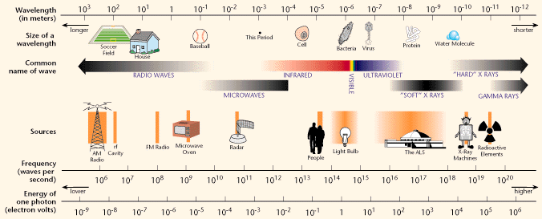

Source: <https://www2.lbl.gov/MicroWorlds/ALSTool/EMSpec/EMSpec2.html>

Fig. 1.3 Electromagnetic spectrum and usage

**1.1 Propagation of EM waves and transmission lines**

We shall start with the transmission of electromagnetic waves. Fig. 1.4 shows the picture of power transmission lines and the associated Electric and the magnetic field lines.

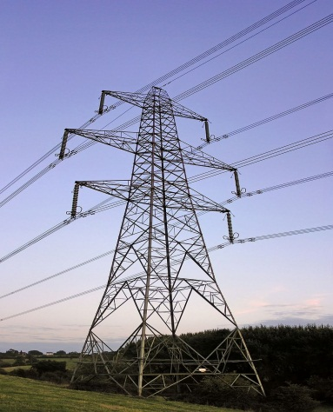 

(b)

B

Y

R

Fig. 1.4 (a)Power transmission line picture: Showing direction of electric field (Blue) and magnetic field (red).(b) Generalized picture electric and magnetic field lines Electromagnetic spectrum and usage

(a)

It is known that there exists electric as well as magnetic field Fig 1.5 shows simplistic equation quantifying these fields.

Charged conductor (charge density) **q/m.**

P

r



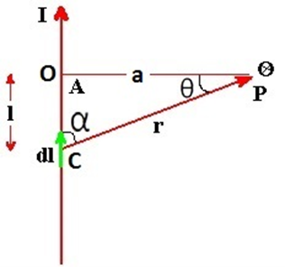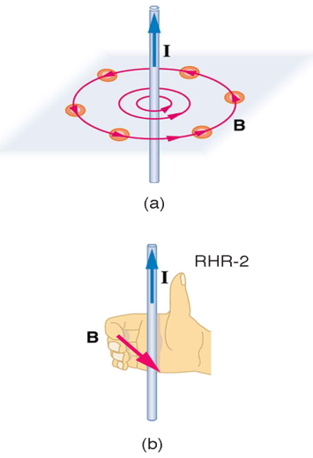

(b)

(a)



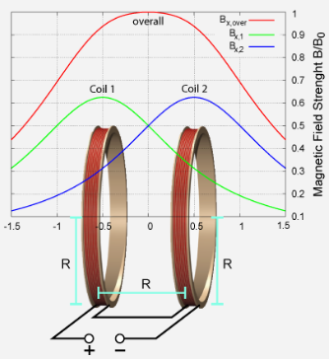

The magnetic field due to Helmholtz coil is given by



Where*,*

*μ0* is permeability=4πX 10-7 Hm-1(or)NA-2.

*I* is current, *N* is number of turns

R is radius and the distance between the coils. It may be noted that for practically uniform field, this condition is necessary.

(c)

Fig. 1.5 (a) The magnetic field at at point P due to the current I is B

(b) Electric field due to a charged conductor at a point P is E

(c) Helmholtz’ coil

In many Engineering applications, Linear magnetic is created using Helmholtz’s coils is used to create uniform magnetic field as shown in fig 1.4 (c).

At higher frequencies, different types of transmission lines are used. Fig. 1.6 shows the field lines for different transmission line structures. Here, the main point which is being stressed that the EM field is present beyond the physical structure of the transmission lines. It is often possible to model electronic system structure as transmission line and the filed strength at the point of interest can be estimated. This approach is generally used to determine circuit parameters like the characteristic Impedance (*Z*), wave impedance (*η*) conducting loss per length and dielectric loss per length. -9999





  

(b)

(a)





 

Fig. 1.6 Different transmission lines and expression for corresponding conducting loss coefficient (***αc***)

(a)Two wire line b) Coaxial lines (c) Parallel plate lines (d) Micro-strip line

The dielectric loss coefficient =where ‘q’ is dielectric filling factor

(d)

(c)

* 1. **Electrostatic and electro-dynamic Induction**

In earlier section, we have seen that the electromagnetic fields extend beyond the physical dimensions of the structure of the transmission line. More generalized statement would be “EM field is present beyond the physical dimensions of any ‘EM energy conveying structures’. In practical situations, different energy conveying structures are formed due to the physical structures of the equipment. These structures provide a propagation path for the EM field present nearby. This results in ‘unwanted presence’ of EM fields or may lead to unintended propagation of EM waves. These phenomena lead to EMI.

We are aware that any charged object when brought near a metal it attracts opposite charged particles and they get distributed near the charged object. This is known as electrostatic induction. Fig. 1.7 shows a concept diagram of ‘electrostatic Induction’. Sudden transfer of electric charge is also known as ‘Electrostatic Discharge (ESD)’. Such discharges cause current surge, rapid drop of voltages. They also cause strong power and ground line currents. These disturbances are generally broad-band (≈10 MHz- 2GHz).

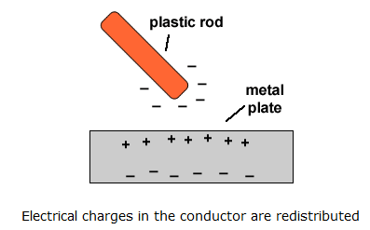

Fig. 1.7 The charge gets distributed in the metal conductor due to charged rod nearby

In the section we are going to get introduced to the effect of the presence of the EM waves. We shall develop this understanding in light of the basic laws as follows:

Ampere’s Law States that moving electric charge(s) can create magnetic field. In other words, any current carrying line(s) create magnetic field in the loop enclosing them (Fig 1.5(a)).

 … (1.1)

and Faraday’s law states that changing magnetic field induces an emf in a closed loop.

This is also known as electromagnetic induction.

 … (1.2)

Fig. 1.7 illustrates a situation where the current in one line may affect (introduce ‘an emf’ in neighbouring line. In the figure 1.5 the current in yellow line produces magnetic field shown by the orange lines. This variable field introduces an EMF in the electric circuit of pink line. This is one of the common mechanisms of EM interference. In common terms it is called ‘crosstalk’.

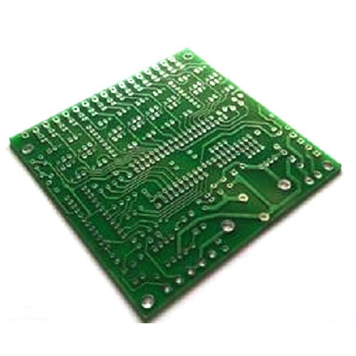

Fig. 1.8 An example of electromagnetic interference due to cross talk on a printed circuit board

Time varying Signal current ‘I’ in the line

Adjacent circuit where emf is induced

Magnetic field lines due to current ‘I’

* 1. **Coupling mechanism of EM energy**

The transfer of electromagnetic energy from one system (or circuit) to other is often refereed as coupling. With intuitive insight developed in from earlier sections, we understand different coupling mechanisms for EM energy.

Following are the different types of coupling of EM energy.

* + 1. **Hard-wire conduction:** This is simply a connection of wires (or transmission lines) where the current flowing through a conductor gets divided into all the paths of the junction. This division is according to the impedance in the path.

In constant voltage (V) power transmission, if the impedances are Z1 and Z2, The current gets divided as V/ Z1 and V/ Z2. The power gets divided as V2/ Z1 V2/ Z2. Whereas, in RF and microwave circuits, the ‘cross wire’ results in different line impedance. This being a circuit of distributed (as opposed to lumped) components, some part of the energy gets ‘reflected’ back to the source and the remaining gets divided into two paths. The procedure of analysis is well established microwave circuit analysis theory.

* + 1. **Resistive coupling:** This type of coupling occurs when there a resistive component common to the two circuits. This path being common change in one part circuit directly affects the other circuit. The analysis of this configuration can be done using Kirchoff’s laws
    2. **Electromagnetic coupling**: These types of couplings are either inductive ( where time-varying signals are coupled to neighbouring circuits due to one of the two mechanisms: (i) Electro-dynamic induction or transformer-like effect and

(ii) Electrostatic induction or capacitive coupling:

Both these effects are presented in section 1.2.

* + 1. **Evanescent wave coupling:** In electromagnetics, an evanescent field, or evanescent wave, is an oscillating electric and (or magnetic) field that does not propagate as EM wave but whose energy is spatially concentrated in the vicinity of the source. This presents itself in form of oscillating charges and currents. When an EM wave is propagating in one medium, this effect is often seen in the adjacent section of different medium.
    2. **Electro-magnetic radiation**: This is the mode where energy is transferred by radiation. One system radiates EM energy and other system receives. Functioning like antenna.

It may be noted that this discussion is about ‘unwanted coupling’. In many systems, the EM energy gets coupled in a non-desirable manner. This phenomenon manifests itself in software errors, erratic response, misleading sensor readings and damage of components. In some cases, the component/ structure responsible for such coupling is easily identified. Identification of these ‘undesirable’ coupling paths generally requires innovative investigative methods.

Having developed an informal insight about the EMI mechanisms, it may worth to see how the non-compliant systems function

* 1. **Performance lacunae in non-EMC compliant systems.**

Fig. 1.9 shows some of the common experience in the year 1970s and Fig. 1.10 shows some events of year 2000s. Fig 1.9 the food processor is the EMI source and the television set is victim system whereas, in Fig 1.10 Cell phone is the source and Computer is the victim.

 

Power lines

Fig. 1.9 Disturbance in television picture due to operation of a food processor in kitchen



Fig. 1.10 Disturbance in computer screen due to cell phone operation

Some of the commonly known examples of EM disturbances are as follows:

**EMI from mobile phone**: It is a pulsed disturbance at frequency bands at 800, 900 and 1800 MHz (depending of the band allotment). They are 577μs pulses repeating at 5.177mswith emission level ≈10 Vm-1.

**EMI in clean rooms** (semiconductor fabrication laboratories): The semiconductor wafers while getting transported in steel carts with insulated wheels, get charged. This charge stay on the steel carts, may get built up and propagate to unintended locations, like sensitive semiconductor devices.

There were many serious military events suspected to be triggered due to the EMI. Some of them are as follows: (Source: “An introduction to Electromagnetic Compatibility”, William. G Duff, Applied technology Institute, Riva Maryland, USA)

(a) USS Forrestal (Vietnam 1969): ZUNI rocket launched by a ship radar, 134 dead, 27 aircrafts destroyed (largest Naval damage after WW II.

(b) HMS Sheffield (Falkland Islands-1982)- Hit by undetected EXOSET Missile! EMI caused degradation in Radar, 21 dead, Ship sunk after 4 days.

(c) Pershing II (Germany) Missile motor exploded during routine maintenance- 3 dead. Electrostatic discharge was identified as cause.

(d) Blackhawk Helicopters (Germany and USA 1987): several potentially fatal incidences and one crash. They were caused due to the interference due to high power radio transmitters.

Taking cognisance of such incidence a formal study, categorization of the EMI and rigorous test procedure was developed. One of the earliest comprehensive documents for equipment was MIL-STD 461. These standards are being implemented since 31st July 1967. These standards have been revised every 8 years and the latest version of this standard is MIL-STD-461 G, released in 2015.

* 1. **Classification of Electromagnetic Interference**

The investigation of the EMI started from the ‘observed undesirable effects’. Major types are listed below

1. Radiation Hazards: Possibility of unplanned explosion in ordinance and fuel.

2. High power RF/ Microwave radiation: Disturbance in radars, flight guidance etc.

3. Electrostatic discharge: False trigger in ammunition, permanent damage to electronic equipment

4. Lightening: It results in a large ‘Electromagnetic Pulse’ or ‘electrostatic discharge’ leading to permanent damage, inadvertent action often leading to destruction.

5. EM Interference from the source equipment on victim equipment: Often lead to temporary malfunction.

The EMI is classified into two main categories as given below. This characterization is based on the mode of attack on the victim system.

(a) Conducted EMI attacks the victim system through the power lines or the signal lines. Fig 1.9 presents an example of the same. An electronically controlled power system uses switching devices like MoSFETs of IGBTs. The operation of these devices results in abrupt variations in the supply current. Due to this other instruments sharing the same supply network may get affected. ‘Electrical Fast Transient’ is also included in this type.

(B) Radiated EMI attacks the victim system through EM radiation in the surrounding space. Fig 1.10 presents an example of the same. Many of the modern equipment operate on wireless communication and message transfer. As a result RF radiation at different frequencies is present in the operating space of almost all the equipment. This RF radiation may affect the operational performance of the systems on which the RF radiation is incident. Electromagnetic Pulse (EMP) is also included in this type.

**1.6 Rationale behind the EMI/EMC standards and compliance tests**

From the foregone discussions it is clear that almost all the EM disturbances are manmade (exists due to another instrument). There are a few exceptions of natural phenomenon like lightening, thunder, meteor showers etc. Therefore there is a need to have standards for all the electrical/electronic equipment.

The EMI/EMC standards ensure that each instrument create a ‘reasonably low’ amount of EMI. This is done by putting certain limits on the ‘conducted’ as well as ‘radiated’ EMI. They are known as ‘emission’ standards; having two sub categories RE (Radiated Emissions) and CE (conducted emissions). The CE is further divided into CM (common mode) and DM (Differential mode) types. EMI/EMC standards, on the other hand, put a benchmark on the ruggedness of electronic equipment. The standard puts a condition that every system should perform in an environment with a ‘reasonable amount’ of EMI. They are known as Immunity or Susceptibility standards, having two sub categories RS (Radiated Susceptibility) and CS (Conducted Susceptibility). Fig.1.11

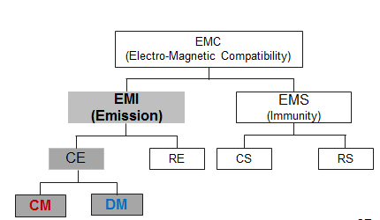

Fig. 1.11 Classification of CMC standards

It may be appreciated that the EMC standards need to be very elaborate. The standards need to define in clear terms ‘Reasonably low’ emission. This will depend on the type of equipment type of functionality and expected environment. Similarly, the environment with a ‘reasonable amount of EMI’ will be different depending on the equipment type of functionality and expected environment etc. Owing to these differences numerous different standards have been in use. Most of these standards differ only by minor factors. Some of them are listed below: (Source: https://en.wikipedia.org/wiki/CISPR and <https://www.iec.ch/emc/iec_emc/>).

All these standards are revised time to time in accordance to the technological developments and user needs.

**1. CISPR:** This is a committee of the IEC (International Electro-technical Commission) the full form is “Comité International Spécial des Perturbations Radioélectriques”. (English translation: OR International Special Committee on Radio Interference)

CISPR have numbers like 11, 12, 14-1, 14-2,.....22,24,25, 32,35. Each of the number is for different types of equipment. As an example CISPR-11 is applicable for Industrial, scientific and medical (ISM) equipment. CISPR -12 refers to Vehicles boats and so on.

**2. IEC:** International Electro-technical commission have standards defined with different numbers in 61XXX series.

**3. ISO**-7637 and other numbers like 11452, 13766 14982 are mainly for road equipment

**4. SAE** (Society for automotive Equipment) EMC standards are for all kinds of on-board transport vehicle equipment. They are numbered as “J11XX, 17XX, 25XX, 55 XX etc.

**5. European standards** are numbered EN-50 XX and EN 55XXX.

**6. FCC standards**: American standards by Federal Communications Commission are in segregated in Part-11, Part 15 etc.

**7. MIL-STD-461** and **MIL-STD-464** current version ‘G’ is in use for strategic electronics whereas **MIL-STD-469** is being used for interface systems.

It may be relevant to note that ‘**CE marking**’ is not an EMC standard. It ‘self certification’ by a manufacturer declaring (with assurance traceable to some authority in European Union) that certain product conforms to ‘some relevant/ applicable’ EMC standards.

These standards are almost mandatory for many applications. Also market entry to any electronic product in Europe requires EMC compliance through CE marking. In other words, any electrical/ electronic products need to have compliance to at least one of the standards.

It may also be appreciated that a technologist working in this area must have knowledge of EMI/ EMC. In order to comply with the standards, the engineer is expected to develop insight in this area and perform system engineering so that the system performs seamlessly in the environment. It is also important to acquire appropriate certification.

The engineer must

1. Have the knowledge of the electromagnetic environment in which the system is expected to function.
2. Have knowledge of the qualifying test specifications and the experimental setup for the same.
3. Design of the system to perform in that environment. The design generally involves: (a) Following good engineering practices while designing, including layout, placement of the components.

(b) Appropriate selection of the protection, noise and transient suppression components is also important.

1. Packaging the system by appropriate assembling the subsystems. This involves use of appropriate grounding and shielding scheme. Using appropriate scheme to interface various subsystems is very important.

Subsequent chapters present discussion on all these points.

**Chapter-2**

**Quantification of EMI and Specifications in EMC Standards**

Having conceptual understanding of the EMI and compatibility standards, we shall develop ‘an association’ of EMI to the real world. In this chapter we shall discuss and understand following aspects:

1. Mechanism of the EMI: How is the EMI created in real-life?

2. Measurement of the EMI: How is the EM interference is quantified?

3. Basis of compliance standard: Rationale behind designing standards.

4. Test setups: How are various EMC tests are conducted?

In chapter 1 we have seen that in modern strategic installations, industry and households many electrical/ electronic instruments are functioning simultaneously. Due to the operation of one unit, the electromagnetic energy generated by it gets coupled / shared with **other instruments**. This coupling could be inductive, conductive, capacitive or radiative as shown in Fig 2.1. This coupling may present in the form of signal or power line variation. In any case, this signal is unwanted to the receiving system. This unwanted signal may lead to malfunction of the receiving system. The system generating the EM energy is called as ‘**Source** of EMI’ and the system receiving the EM energy is called the **‘Victim’**.

It may be noted that there is no component or gadgets for the coupling of EM energy. It is often the physical structure that makes the coupling of EM energy happen! This is unintentional and takes place due to non-ideal components or equipment structures. Some of the real-life examples are mentioned in section 1.4.

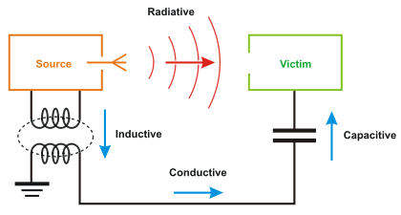

Fig. 2.1 Modes of EM coupling

We have also known that the EM coupling types are as shown in Fig 2.2.

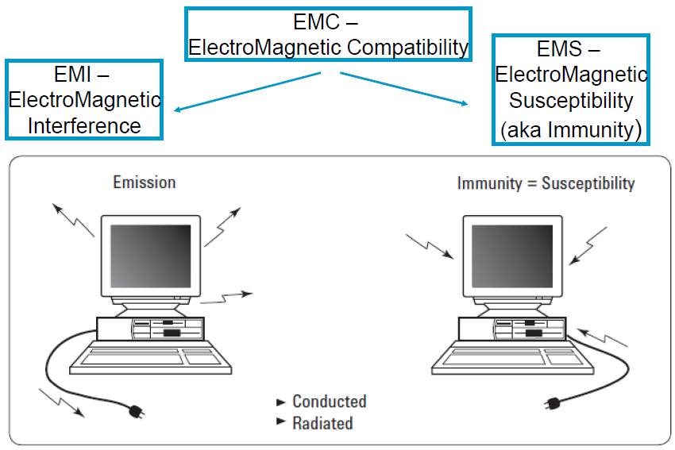

Fig. 2.2 Types of EMI, definitions

The EM energy emission and reception is measurements are defined in reference to the frequency bands. This means power emitted over certain frequency limits in certain frequency bands is measured and the limits are defined for acceptability. We illustrate this with an example of a ‘12V-5V Switched-mode power supply (SMPS) which was subjected to ‘CE-V’ test (CISPR-25, voltage method) Fig 2.2 shows the emission spectrum for a unit which failed the test. Fig. 2.3 shows the spectrum of similar unit which passed the test.

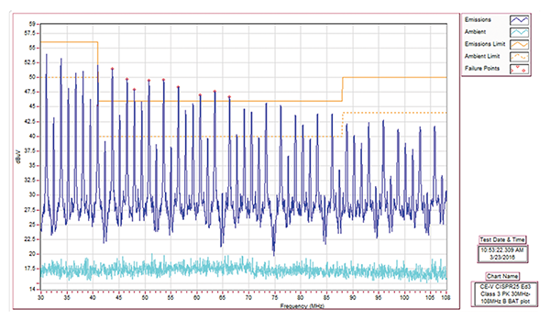

Fig. 2.1 EM coupling mechanism with terms used by EMC professionals

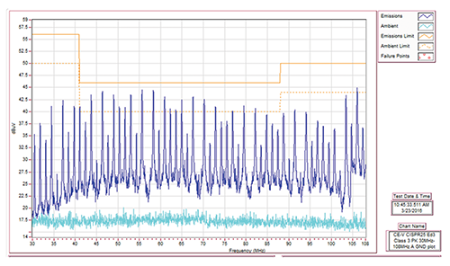

Fig. 2.2 Spectrum of a failed unit ‘conducted emission test’ (CISPR-25, voltage method)

Source: <https://incompliancemag.com/article/conducted-emissions-measurements-voltage-method/>

The graphs in Fig.2.2 and 2.3 show the ‘conducted emissions’ (blue line) of the SMPS (device under test, DUT) and the ambient (cyan line) respectively. The emissions are measured in voltage magnitude of the emissions in the ‘measurement band (resolution bandwidth)’. This is measured in logarithmic units, dBμV. The limits are shown by orange lines, dotted for the ambient emissions and the bold line for the DUT emissions. Fig. 2.2 shows that 9 components (in the band approximately 44 MHz to 66 MHz) shown higher emissions (indicated by the red dot) than the limit. Therefore, the DUT is declared as failed. On the other hand, emission all the components in Fig. 2.3 have lesser voltage than the limit. Therefore, the DUT is declared as ‘Passed’.

In the subsequent sections, we shall discuss EMC tests details in the following sections of this chapter.

**2.1 Units-definitions and usage**

The EM measurements are almost always expressed in logarithmic/ decibel (dB) scale. The dB scale represents any quantity ‘relative to’ some reference quantity. This originates from the first usage in the measurement of ‘sound Pressure Level (SPL)’. The sound pressure level is measured with respect a reference level of 20μPa (threshold of Human hearing capability). This means that 0dB corresponds to SPL of 20μPa, 20 dB SPL corresponds to 200 μPa and so on. Mathematically, sound pressure level and dB SPL are related by

 … (2.1)

This approach is used to express any quantity in the dB scale. However, on has to indicate the reference unit after dB. This means that the current ‘in dBA’ will be expressed as

 … (2.2)

It may be noted that if the measured parameter is in Power terms, the expression becomes as follows.

 … (2.3)

The electric field is measured with reference to (w.r.t.) μVm-1. Hence is measured in

 … (2.4)

Similarly, dBm power w.r.t. 1mW. All other quantities are expressed in dB scale with the logic. As an example, the spectral graphs in Fig. 2.2 and Fig 2.3 show voltage measurements in dBμV (dB scale w.r.t. 1μV).

* 1. **Frequency bands and Measurement Environment in EMI/EMC standards**

The EMC standards are defined over the frequency range of 9 kHz to 40 GHz. Fig. 2.4 gives a representative example of the frequency bands and corresponding devices/ applications responsible for it. On this basis, depending on the function of the device under test (DUT) and the EM environment of the application, the frequency band and limits are decided. As an example, the units used for strategic applications have more stringent tests compared to the household appliances.

These standards and frequency bands are revised from time to time. The technological advancements and change in the EM parameters in the working environment are the driving factors behind the changes. As an example, in MIL-STD -461 C RE-02 had the frequency band of 14kHz to 10 GHz. This was updated in the revision D of the MIL-STD-461 as 10 kHz to 18 GHz.

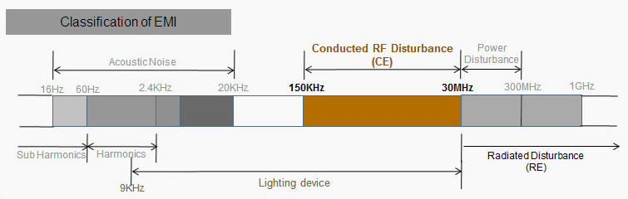

Fig. 2.3 shows approximate frequency bands where the disturbances are practically observed.

* Audio disturbance is observed in the frequency band of 16 Hz to 20 kHz. Though it is important, it is out of scope of this course.
* Conducted disturbance presents itself as variation in the currents in the power and signal lines. It is generally observed in the frequency band of 130 kHz to 30 MHz. Modern power electronic switching devices like MoSFETs and IGBTs create disturbances up to 300 MHz.
* Radiated disturbances are created in the VHF bands and above (30 MHz and higher frequencies. These differences occur when the current variations in the system lead to EM radiation. The EM radiation takes place when the current carrying conductors in the system behave as ‘antennas (or the radiating elements)’. Generally electronic structures radiate when the physical dimensions of the conductors are comparable to the wavelength of the EM wave. Therefore it is logical to expect radiated disturbances above 30 MHz (λ=10m).

As mentioned earlier, there are different standards for different DUTs and operating different application areas. These standards and the numerical limits on various parameters are decided as follows:

* The susceptibility limits are decided on the basis of ‘extend of disturbance’ The DUT is likely to encounter while performing in the intended environment of operation.
* The emission standards have parameter limits so that the DUT does not disturb other units operating in the vicinity.
* If the DUT is expected to be operated in close vicinity to the human beings, the limits also ensure that emissions do not lead to biological hazards.

We shall understand these concepts with reference to the MIL-STD-161 G. Sections 2.3 and 2.4 describe some of the representative conduction and emission tests respectively.

**2.2.1: General description of EMC tests:**

All the EMC tests are conducted in an ‘electromagnetically quiet’ environment. This means that the test environment must not have any radiations or conducting signals (on the power/ signal lines) that are not connected to the equipment (DUT as well as the testing instruments.

Emission tests are conducted by measuring the emissions, conducted (on power and signal lines) or radiated (in the space around the DUT) with appropriate equipment.

The susceptibility tests are conducted by imparting EM radiations on the DUT or injecting conducted EMI on the DUT signal and power lines.

**2.2.1.1 Tolerances:** These tests are conducted with rather relaxed tolerances.

For MIL-STD-161 G, they are the same unless otherwise stated for a particular measurement. The tolerance for MIL-STD-161 G, are as follows:

* Distance: ±5%
* Frequency: ±2%
* Amplitude, measurement receiver: ±2 dB
* Amplitude, measurement system: ±3 dB

(this includes measurement receivers, transducers, cables, and so forth)

* Time (waveforms): ±5%
* Resistors: ±5%
* Capacitors: ±20%

**2.2.1.2 Shielded Enclosures**

In most of the cases, the interaction between the EUT and the outside environment, needs to be prevented. Shielded (or anechoic) enclosures are generally used for such testing. These enclosures prevent external environment signals from contaminating emission measurements and susceptibility test signals from interfering with the circuitry of the DUT and the measuring equipment. Shielded enclosure is expected offer adequate attenuation such that the ambient requirements of the tests are satisfied. The enclosure is expected to be sufficiently large such that the EUT arrangement requirements for the tests are possible. The test arrangements generally include the distance between the DUT and antenna (for measurement or imparting radiation) and the space required to position the antenna.

Shielded chambers are metallic boxes internally lined by suitable RF absorbing materials; see Fig. 2.5. The RF absorber material is of different types; namely, carbon impregnated foam pyramids, ferrite tiles, pours ceramics and so forth. Table 2.1 gives the specification of the absorbing material. The absorbing material must ensure that the ambient radiation is at least 6dB below the allowable limits in all frequency bands under consideration. The ‘electric field radiated emission’ or ‘radiated susceptibility’ tests are performed inside shielded enclosure. This reduces reflections of electromagnetic energy and to improve accuracy and repeatability of the measurements. This concept is similar to what is used while constructing high quality audio recording studios. Fig. 2.6 (a) and 2.6(b) show the picture of the interior and plan (top view) of a typical shielded chamber respectively.

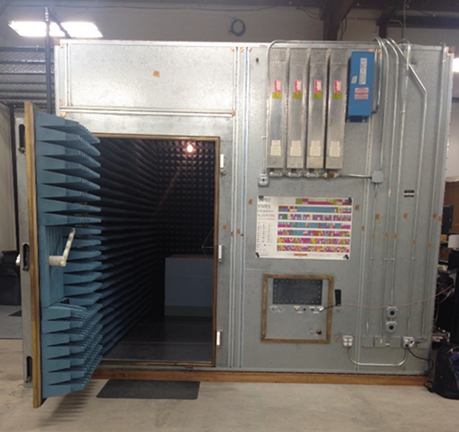

Fig. 2.4 External view of anechoic/ shielded chamber

 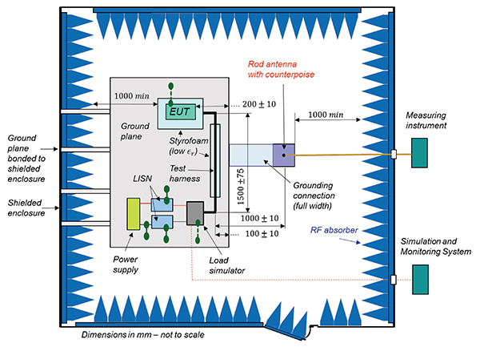

Fig. 2.5. (a)Picture of the interior of shielded enclosure (b )Plan showing the arrangement for EMC tests

Table 2.1 Specification for the absorbing material

|  |  |
| --- | --- |
| **Frequency** | **Minimum Absorption** (at normal incidence) |
| 80 MHz- 250 MHz | 6 dB |
| Above 250 MHz | 10 dB |

**2.2.1.3 Power Source Impedance**

The impedance of power sources must be stable irrespective to the operation of the DUT. If this is not the case, the voltage and current values could vary simply due to the ratio of the source to load (DUT) impedances. For this purpose, Line Impedance Stabilization Networks (LISNs) are used for all measurement procedures (unless otherwise stated in a particular test procedure). It plays similar role for conducted signals as the shielded chambers for the radiated signals. The LISNs is located at the power source end. Fig 2.6 shows the circuit schematic of the LISN. It may be appreciated that the Inductor must the required current rating.

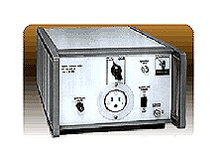

Fig. 2.6 The circuit Schematic of LISN and An LISN model 11967D of Keysight

**2.2.1.4 Ground Plane**

The Device under test (DUT) or equipment under test (EUT) must be tested with appropriate ground plane which imitates actual working condition. In case of multiple operating conditions, metallic ground plane of minimum size of 2.25m2 must be provided. If the operating conditions demand absence of ground plane the tests shall be conducted on non-metallic surface like that of wood. Fig. 2.7 shows a sketch of general test set-up with conducting ground plane and Fig. 2.8 shows the sketch for tests on non-conducting plane.

**2.2.1.5 Measurement for susceptibility and emission tests**

During the susceptibility tests the test equipment imparts radiation or inject conductive disturbance on the power as well as signal lines. The DUT functioning is assessed with any method that will provide visual indicators. Or certain ‘Built-in Test (BIT)’ prescribed for the DUT. However, the emission measurements are done by carefully measuring the radiated energy or conducted disturbances at all the frequencies of interest/ under consideration. The unit (DUT) must also be oriented in such a manner that it produced maximum radiated emissions and respond to the external emissions. In simple words, it means open/ unshielded face should point away from the ground plane.

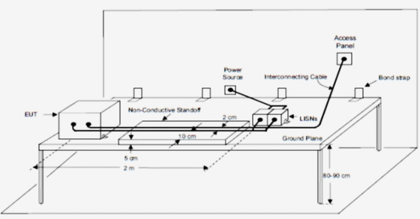

Fig. 2.7 EMC test set-up with ground plane

Accurate signal measurement requires a detector. RF and microwave energy can be detected with semiconductor detectors or with bolometric (output proportional to absorbed energy, or the mean squared value) detectors. This method does bring out the ‘disturbance potential or annoyance level’ of transients/ peaks; therefore, MIL-STD-461 requires peak detector for emission and susceptibility measurements. This device detects the peak value of the amplitude envelope in the receiver pass-band. Measurement receivers are calibrated in terms of an equivalent Root Mean Square (RMS) value of a sine wave that produces the same peak value. This means, for one sided measurements, the peak value is multiplied by 1/sqrt(2) or 0.707 and by by 0.35355339 for two sided measurements. Other measurement devices such as oscilloscopes, non-selective voltmeters, or broadband field strength sensors, when used for susceptibility testing, are calibrated (multiplied by correction factors) to match the reading to equivalent RMS values corresponding to the peak of the modulation envelope. Here, it is assumed that the detector is ideal, (or faster than Bandwidth of the measurement receiver).

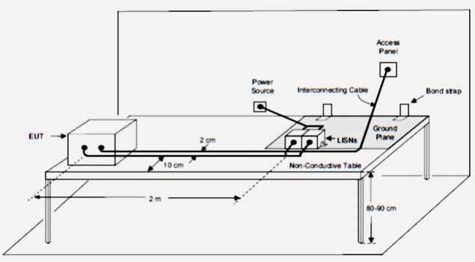

Fig. 2.8 Set-up for EMC tests with non-conducting plane

However, CISPR and many other industrial standards use a quasi-peak detector, as defined in Publication 16 of the International Special Committee on Radio Interference (CISPR) of the International Electro-technical Commission (IEC). In brief, the CISPR quasi-peak detector is a peak detector with an ‘attack time’ of 1 ms, a decay time of 500 ms and an IF filter setting of 100 kHz.

‘Attack time’ is a term used in telecommunications. It is the [time](https://en.wikipedia.org/wiki/Time) between the instant that a [signal](https://en.wikipedia.org/wiki/Signal_(information_theory)) at the input of a device or [circuit](https://en.wikipedia.org/wiki/Telecommunication_circuit) exceeds the activation threshold of the device and the instant that the device or circuit reacts in a specified manner, to the input. The measured value is the values held on the capacitance of the detector. In [audio quality measurement](https://www.revolvy.com/page/Audio-quality-measurement), quasi-peak rectifiers are specified in several standards; for example, [ITU-R 468. This was originally done because the quasi-peak detector was believed to better indicate the subjective ‘annoyance level’ experienced by a listener hearing impulsive interference to an ‘[AM](https://www.revolvy.com/page/Amplitude-modulation) radio station’. This incorporates noise weighting](https://www.revolvy.com/page/ITU%252DR-468-noise-weighting) or the uses of rectifiers with two cascaded time constants. In other words, a ‘quasi peak detector’ is a detector that is deliberately made slow. This is generally done by adding some capacitance.

The ‘decay time is the [time](https://en.wikipedia.org/wiki/Time) taken for the amplitude of a [pulse](https://en.wikipedia.org/wiki/Pulse_(signal_processing)) to decrease (fall) from a specified value (usually 90% of the peak value exclusive of [overshoot](https://en.wikipedia.org/wiki/Overshoot_(signal)) or undershoot) to another specified value (usually 10% of the maximum value exclusive of overshoot or undershoot).

Conceptually, a quasi-peak detector (for [EMC](https://www.revolvy.com/page/Electromagnetic-compatibility) testing) works like a peak detector followed by a lossy integrator (or a Low pass filter). The Quasi-peak extracts the underlying [baseband signal](https://www.revolvy.com/page/Baseband-signal) consisting of the slow (relative to the receiver centre frequency) time-varying amplitude of the impulsive oscillation. So the measured output for a sequence of impulses is higher when the pulse repetition rate is higher. The quasi-peak detector is also calibrated to produce the same output level as a peak-power detector when the input is a [continuous wave](https://www.revolvy.com/page/Continuous-wave) tone. Fig. 2.9 illustrates that for sinusoidal signal of 100 Hz, say. The Quasi-peak mean matches the RMS level, as it decays to 0.414 (≈ e-0.88) times the peak. The decay takes 0.817 times the period (T). Hence, the decay time constant ‘0.928 X T’.

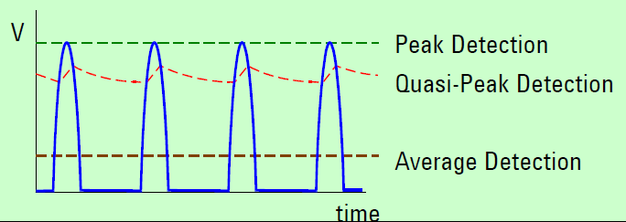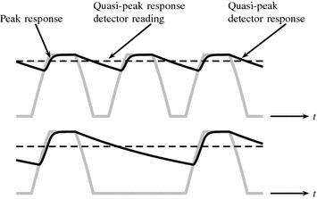

Attack time

RMS level

ecay time

Decay time

(a) level difference between peak and quasi-peak (b) Quasi-peak level due to different repetition rates

Fig. 2.9 Quasi-peak detection and calibration

For the measurements, it is also necessary to specify, the steps of individual measurement bandwidths and the scan time for each of the bandwidth while scanning the band of interest. Table 2.2 and 2.3 present these specifications.

Table2.2 Bandwidths and the measurement time

|  |  |  |  |
| --- | --- | --- | --- |
| **Frequency Range** | **6 dB Resolution Bandwidth** | **Dwell Time** | |
| **Stepped Tuned Receiver (seconds)** | **FFT Receiver**  Sec/ (measure. BW)-1 |
| 30 Hz-1 kHz | 10 Hz | 0.15 | 1 |
| 1 kH-10kH | 100 Hz | 0.015 | 1 |
| 10kH-150kHz | 1 kHz | 0.015 | 1 |
| 150kHz-10MHz | 10kHz | 0.015 | 1 |
| 10MHz-30MHz | 10kHz | 0.015 | 0.15 |
| 30MHz-1GHz | 100kHz | 0.015 | 0.15 |
| Above 1 GHz | 1MHz | 0.015 | 0.015 |

Table 2.3: Susceptibility scanning rates

|  |  |  |
| --- | --- | --- |
| **Frequency Range** | **Minimum rate: Analog Scan** | **Maximum size: Stepped scan** |
| 30Hz-1MHz | 0.0333 f/sec | 0.05 f |
| 1MHz-30MHz | 0.00667 f/sec | 0.01 f |
| 30 MHz-1 GHz | 0.00333 f/sec | 0.005 f |
| 1 GHz- 40 GHz | 0.00167 f/sec | 0.0025 f |

**2.2.1.6 Antenna Factor**

The EM field measurements are taken with the help of calibrated antennas. These antennas serve the same purpose as the transducers in instrumentation. Antenna is a ‘one port’ device. It receives EM radiation/ energy and converts into voltage at the terminals/ connector/ port. In electromagnetics, the antenna factor (AF) is defined as the ratio of ‘magnitude of electric field strength (***E***)’ (on the antenna aperture) to the ‘voltage induced’ at the antenna port. The induced voltage value at the terminals of the antenna depends on actual antenna gain, aperture characteristics and the loading effect or the impedance matching. Equation 2.5 gives the definition of the antenna factor and the relevant units. It may be noted that AF is a scalar quantity. It is assumed that the electric field (to be measured) is aligned to the antenna polarization. Therefore, the radiated emission (RE) tests are done with measurements in all the 3 axis positions and the similarly, radiation is imparted in three axis position while imparting it on the DUT for the radiated Susceptibility (RS) tests

 … (2.5)

Expressing in dB

 … (2.6)

Magnetic loop antennas convert ‘magnetic field strength (***H***)’ (units A.m-1) to the voltage. Hence the units for the antenna factor are A.V-1.m-1. Some earlier literature uses these different units for the magnetic loop antennas. However, modern usage standardizes the measurements in electric field strength units. For this purpose, we use the expression for the free space impedance (***Z0***). Needless to say that parallel plane

 … (2.7)

The radiated EM energy is often expressed as power density, Power incident on unit area (). The received power at the antenna port (*Pr,W*)The inter-conversion between various terms can be done as follows:

 … (2.8)

 … (2.9)

We also use the expression for effective area and antenna gain (*G*)

 … (2.10)

Where,

***Ae***:- Antenna Effective aperture ***λ*** :- Wavelength of EM radiation,

***R***- Characteristic Impedance at the port ***μ0,ε0*** :- Permeability permittivity of the free space

We get some simplified expressions as follows:

 … (2.11)

Measurements of other quantities like current, voltage are done by standard instruments and sensors

**2.2.2 EMI Measurement instruments**

In earlier section, we have seen that the radiated emission and susceptibility tests are done in a shielded enclosure or the anechoic chamber. This chamber provides an “electromagnetically quiet’ environment. We have also learned that inside the chamber/ enclosure, the EM field strength must at least be 6dB below the specified acceptable limit for the test. We have also seen the Line impedance stabilizing network (LISN) suppresses the conducting noise and the reflections created by ‘un-matched impedances’. The bench (shown 2.7 and 2.8) ensure appropriate grounding for the DUT.

Additionally, for the tests, we need measuring equipment(s) and the instruments which create and impart the ‘disturbance signal’. In this section we shall get introduced to major equipment in this category.

**2.2.2.1 EMI Receivers**

The measurements are done by EMI receivers. Many international players manufacture these instruments; namely, MXE- BN9038A from Keysight (formerly Agilent), ESR xx series from Rhode and Schwartz (R&S), 15xx series from Schwarzbecks. EMI -9KB/C from Lisun and so on... Fig. 2.10 shows the front view of R&S ESR and Keysight-MXE.

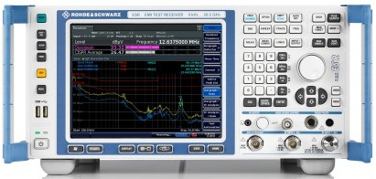 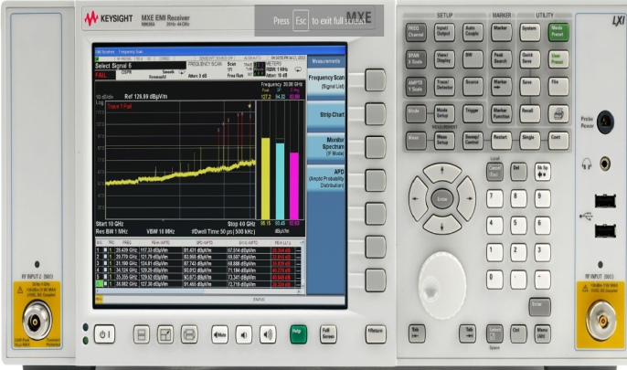

1. R&S ESR series (b) Keysight -MXE

Fig. 2.10 Representative picture of EMI receivers from two of the leading manufacturers

These EMC receivers are fundamentally ‘swept spectrum analysers’ with ‘pre-loaded settings’ EMC standards. Most of the manufacturers provide CISPR and MIL-STD-461 settings as a standard feature. In the section 2.3 we shall see that the EMC tests require that the signals to be measured at a particular frequency bands with particular ‘frequency resolution’. These instruments have an overlaying application of multiple tests which show the acceptable limits for particular tests and identify and enumerate the components which cross the limits. Due to this facility, the user is required to specify the only the ‘test number’ (e.g. MIL-STD 461G- RE01). The instrument generates the spectrum and the details required for the report. It may also be noted that the EMC receiver must have the measurement accuracies equal (or better) to what is specified for the corresponding EMC tests. Section 2.2.1.1 and 2.2.1.5 specify the accuracies and the conditions required for the ‘MIL-STD-461 G’ tests. In addition the EMC receives is required to pass the RE immunity test at the field strength of 3V.m-1.

In order to appreciate these terminology, the reader is advised to get familiar with various settings like ‘resolution bandwidth (RBW)’,‘Reference level (RL)’, Sweep rate (SWR)’ in the context of spectrum analyser and their effect on the signal strength/ display.

Fig 2.11 shows the functional block diagram of a swept spectrum analyser.



Fig. 2.11 Functional block diagram of swept spectrum analyzer

There two methods of measurement of frequency components, namely frequency sweep method and the FFT method. In the frequency swept method the signal is subjected to a narrow band filter of desired resolution bandwidth. This filter is swept in the frequency by changing the local oscillator (LO) frequency of the mixer. The sweep generally takes more time. The other method (of using the FFT) the signal is subjected to a larger bandwidth signal (N times the RBW, N is the number of FFT points). The signal strength in each narrowband is computed by the FFT algorithm. Fig 2.13 shows the schematic difference these two methods. This technique allows faster sweep time.

Most of the measuring equipment display the average power received in the RBW. This value may show some difference in the power level due to the sweep time as well as the ‘resolution bandwidth (RBW) selectivity’ or the shape factor. Fig. 2.14 illustrates the shape factor with reference to the filter characteristics. The sweep time decides the resident time in each RBW. This resident time is computed by the expression 2.12.

 … (2.12)

The displayed power is proportional to the resident time in the RBW.

The filter executed by the FFT algorithm has the shape of Sinc {sin(x)/x} function. Whereas the filter executed by the digital filter (operated in sweep mode) is often sharper (less value of selectivity, or finer selectivity). The value of selectivity is given by (2.13).

 ... (2.13)



(a) (b)

Fig. 2.13 Computation of the frequency components by (a) FFT method (b) Swept filter



Fig. 2.14 Shape factor of selectivity of a filter

Due this fact (use of filters with different selectivity) the displayed power value at the same resolution bandwidth could be different by around a dB. The effect of different type of equipment and different type of analysis on power measurement is illustrated by example in Fig. 2.15. This illustration shows an example when a single frequency signal at 1.868.5GHz, and power of -100dBm is subjected to 3 different methods of spectral measurements. This signal was observed with ‘video bandwidth (VBW) of 3 kHz, and resolution bandwidth (RBW) of 3 kHz on following different conditions on Keysight (earlier Agilent/ hp) spectrum analysers:

(a) **8563E**C (analog, sweep time of 280 sec; maximum of 840 μs per measurement)

(b) PSA series equipment (digital swept filter technique, sweep time of 134 sec)

and (c) PSA series equipment (FFT technique, sweep time of 13.5 sec).

The corresponding readings are

(a) 1.867 GHz, -102 dBm, (b) 1.870 GHz -100.36dBm (c) 1.867GHz, -100.73dBm)!

Allowing for these variations the EMC specifications allows tolerance of ±2dB in amplitude and ±2%. In frequency, as mentioned in 2.2.1.1.



Fig. 2.15 Display of @1.868.5 GHz signal on different spectrum analyzer systems of ‘**Keysight Technologies**’

(Source: Application note by Giuseppe Savoia, Agilent Technologies)

(Source: Application note by Giuseppe Savoia, Agilent Technologies)

**2.2.2.2 Field Strength Measurement Unit**

In radiated emission (RE) tests, it is required to measure electrical field strength. This measurement is done using calibrated (whose antenna factor is known at the measurement frequency) antennas and an EMI receiver or any RF power measurement instrument.

Electric field strength is measured in Vm-1 (Volts per meter). For small field strengths, of EMI tests, we have logarithmic unit🡺 dBμVm-1. The RE tests require measure of the field at some specific distance from the DUT. We have following expressions for the inter-conversion of the relevant quantities. For an isotropic radiator, power density at a distance ‘***r***’ is given by

 … (2.14)

Where, ***PD***is power density, ***Pt*** is transmitted power by the source, ***R*** is the free space impedance, ***E*** is the electric field strength and ***r*** is the distance from the source.

Substituting the value of ***R***,

 … (2.15)

The measurements are done with calibrated antenna (known AF) places at a distance specified in the test specification. This antenna is connected to an EMI receiver, spectrum analyser or frequency selective power meter, which displays the power in dBm. The inter-conversion expressions are as follows.

All measurement systems work with standardized port impedance of 50Ω.  … (2.16)

Putting in dB terms, we get conversion expression for power (dBm) to voltage (dBμV)

 … (2.17)

On power measurement, knowing the antenna factor (AF), electric field can be calculated using the following expression.

 … (2.18)

A representative picture of field measurement set up is shown in Fig. 2.16.

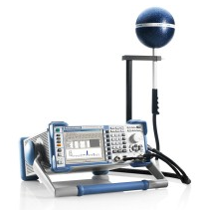

Fig. 2.16 EMI receiver with antenna

The frequency range of measurement is decided by the antenna operating bandwidth. Typically, 3 to 4 antennas cover the frequency range required for the EMC tests. 2.17 show the representative pictures of popular antenna types used for the EMC tests and their frequency bands of operation.



1. Bi-conical (b) Log Periodic (c) Double ridged horn

Fig. 2.17 Operating frequency (a) 25 MHz-300MHz (b) 80 MHz – 3 GHz (c) 0.8 GHz-16 GHz

EMC analysis often require ’close field probes’ or near field probes; popularly known as sniffer probes. These probes generally measure magnetic fields. They are either loop type or pointer type. Fig. 2.18 shows the sketch of the probes and pictures of some products.

 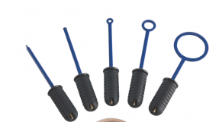

1. (b)

Fig. 2.17 (a) Sketch showing working of pointer type probe (b) pictured of sniffer probe

(Source for (a) Application note by Giuseppe Savoia, Agilent Technologies)

**2.2.3: EMI generating instruments**

After getting introduced to measuring equipment and sensors, we shall have a look at the EMI generating equipment. We know that the Susceptibility tests require the generation of the EMI signals and these signals need to be imparted on the DUT in appropriate manner and in appropriate direction. Description of some of the main instruments is presented in forthcoming subsections.

**2.2.3.1 RF signal generator and power amplifier**

All the susceptibility tests involve generation of a specific signal. This signal is amplified to a required level. And then the signal is imparted on the DUT with suitable applicator instrument. RF signal of desired frequency is generated by synthesized sweep signal sources. These sources are capable implementing the frequency sweep (continuously increasing or decreasing) in any frequency band. This signal is subjected to a wide-band amplifier unit to enhance the signal at desired level. Many such instruments are available in global market. Fig. 2.18 shows a model No. 8365B synthesized swept-signal generator 0.01-50 GHz, model No. 8365B from Keysight Technologies and an amplifier unit (model no 175S1G4, 0.8-4.2 GHz, 175 watts) from Amplifier Research Corporation.

 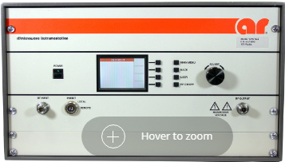

1. Swept signal Generator (b) RF Amplifier

Fig. 2.18 Picture of commercially available signal source and RF amplifier

**2.2.3.2 RF signal generator and power amplifier**

Many of the CS tests require that the DUT is subjected to Electronic signal burst or fast transient electrical signal at different levels. Typically voltage spikes up to 7000 Volts and pulse rates up to 1 MHz are used in these tests. Fig. 2.19 (a) shows the picture of EFT 500N8. This unit is capable of generating pulses specified in IEC 61000-4-4:2004, IEC 61000-4-4 Amd.1 Ed.2:01/2010 and IEC 61000-4-4 Ed.3. A specialized unit is needed to induce ‘burst/ EFT’ signal to the power and data lines. This units is also shown in Fig. 2.19 (b)

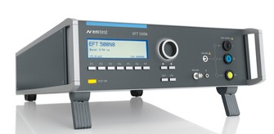 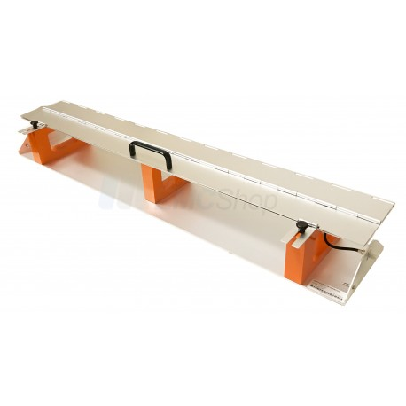

Fig 2.19 (a) EFT generator (b) Burst/ EFT coupling unit

**2.2.3.3 Testing for the Electromagnetic Pulse (EMP)**

Military equipment used in open air, rugged environment, is required to undergo testing for the EMP. Time domain waveform of IEC 61000-2-9/10/11 is shown in Fig. 2.20. Sharp pulsed, high intensity EM field requires a special set up; See Fig. 2.21, shows the set-up for large units and vehicles. Such set-ups are required as it is impractical to create TEM field using antenna; as the power density reduces with distance. There are two main types, of EMP tests; namely, ‘nuclear EMP (NEMP)’ and ‘High altitude EMP (HEMP).

Smaller DUTs are subjected to EM field in a TEM cell. Fig. 2.22 shows a sketch showing the construction of a TEM Cell.

With this introduction of the test equipment we precede to the some of the representative EMC test specification.



Fig 2.20 (a) EFT generator Swept signal Generator (b) Burst/ EFT coupling unit



Fig 2.20 (b)Test set ups for EMP tests for large units

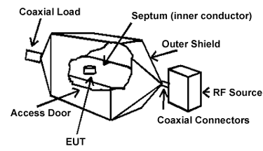advantage vertical field

Fig. 2.21 Set up for EMP tests of a small units

* 1. **Tests for Conducted EMI**

We are aware that the EMC tests are broadly classified in two |

Table 2.4 Various EMC tests In MIL-STD 461-G (Source: draft document on 2nd March 2015)



These tests are applicable for different functionality and environment of the DUT. Table 2.5 shows applicability matrix for MIL-STD-461G. It is seen that some tests are directly applicable (indicated by A), whereas some tests are applicable with different limits or limits specified by the user (indicated by L and S respectively).

Table 2.5 Applicability (or requirement) matrix for the EMC tests

(Source: MIL-STD-461G draft document on 2nd March 2015)



**2.3.1 Conducted emission test on power leads (CE 101)**

This test is conducted with DUT arranged as shown in Fig. 2.7 or Fig. 2.8 and the measurement s are taken using current probe. The Block diagram of measurement set up is shown in Fig 2.22 system check arrangement is shown in Fig 2.23. This set-up is used as calibration by mapping the current probe output measured by the measurement receiver to the current computed from the oscilloscope readings

 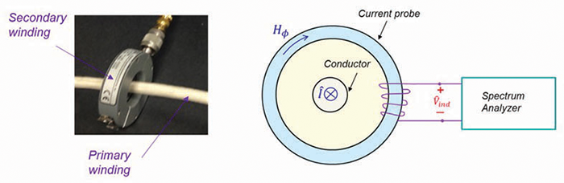

Fig. 2.22 (a) Block diagram for the set up for CE 101 (b) Current probe measurements



Fig. 2.23 Set-up for the measurement system check

The allowable limits for the CE 101 are shown in Fig 2.24.It may be noted that these limits changes for AC-50 AC 400 Hz power source. The limits also change for the aircraft applications.



Fig. 2.24 CE 101 limits for surface ships and submarine (DC power source)

**2.3.2 Conducted emission test on Antenna ports (CE 106)**

Conducted Emissions tests at antenna terminals is different as passive units do not have own emissions. The emissions should not exceed the values given below: Here the voltage is measured at the terminals.

1. In the standby mode, the voltage at terminals of Receivers, transmitter and amplifiers ≤ 34 dBμV. In the transmit mode, all the harmonics, except 2nd and 3rd must be least 80dB below the fundamental frequency component. The 2nd and 3rd harmonic components will be supressed to -20 dBm or 80 dB below the fundamental.
2. All spurious components shall be limited to <-40dBm. If the duty cycle is <0.2%, this limit is extended to 0dBm. It can be seen that the limits are ‘conditional’. These conditions are dependent environment. For different environment sometimes different test (e.g. CE102) are defined. The test set-up is shown in Fig. 2.25. The emissions often have The transmission from the antenna may have frequency components which are not of interest of conducted emissions; e. g. the radiated RF frequency. A ‘rejection network’ for such frequency components is often included in the test set-up.



Fig. 2.25 The test set-up for CE 106 test

**2.3.3 Conducted Susceptibility tests (CS101)**

The conducted susceptibility tests the ability of the DUT to perform when conducted disturbance is present. This test is conducted on AC leads with ≤ 30A per phase and DC power leads. The frequency range is 30 kHz to 150 kHz. The disturbing signal is coupled to power leads using coupling transformer, in the manner shown in the schematic of the set-up; see Fig. 2.26. The DUT is certified as ‘passed’ when it does not show any degradation with the disturbance signal induced on the power leads. The calibration set up is shown in Fig. 2.27. and Fig 2.28 show the limit of the induced signal



Fig. 2.26 The test set-up for CE 101-4 signal injection on DC or single phase



Fig. 2.27 The calibration set up for CS101 test



Fig. 2.28 Signal limits of induced signal for CS101 test for all applications

The CS tests are also defined for the antenna leads, three phase power supplies, hand held units. The test set ups are appropriately modified for DUT of different configurations. These tests are also have separate numbers; e.g. CS 104, CS 105, CS 109 etc. Other Industry standards also have similar methodology for defining the standards.

There are more tests in conducted susceptibility corresponding to special waveforms. These types of signals are encountered by the system while operating. A brief discussion on these additional tests is as follows. The MIL standard defines test setups and calibration/ verification setups for all these tests.

* **CS 114:- Bulk cable injection test**: Signal of 10kHz to 200 MHz are coupled to all interconnecting cables (Including the power leads) of the DUT. These limits are slightly lower in strength compared to CS106 tests but span much large frequency band.
* **CS 115**:- **Bulk cable injection, impulse excitation test:** In this test, an excitation signal consisting a pulse train of 30 ns/ 5A pulses at a repetition rate of 30 kHz is coupled to all interconnecting cables (Including the power leads)to in DUT.
* **CS116:- on cables and power leads, damped sinusoidal transient excitation:** This test injects a damped sinusoid signal of mathematical expression (2.19) with a damping factor Q=15±5. Typical signal waveform is shown in Fig 2.29. This test is conducted over the frequency range of 10 kHz to 100 MHz. The amplitude profile of the tests is given in Fig. 2.30



Fig. 2.29 Damped Sinusoid waveform for the CS 116 test.

 ... (2.19)

If the sinusoid decays to approximately 50% of the amplitude at Nth cycle, then the damping factor is defined as

 Where, *Ip* and *In* are the magnitudes of 1st and *Nth* (50% decay) peak ... ( 2.30)



Fig. 2.30 Amplitude profile (w.r.t. frequency) of Damped Sinusoid waveform for the CS 116 test

* **CS117:- on cables and power leads, lightening induced transient excitation:** This test has 5 sub types and each of the types injects sharp pulses with envelopes simulating different type of lightning strikes. These waveforms have rise time of a few hundreds of nanoseconds and fall time of a few microseconds.
* **CS118:- Personnel borne electrostatic discharge:** In these tests an electrostatic generator discharges static charge to the body of DUT. This discharge is administered with electrostatic probes. The contact discharge probe has a sharp tool and discharges through capacitance of 150pF and discharge resistance of 330 Ω. The voltage levels are 2kV to 8kV (according to applicability). This voltage is applied by touching a charged probe (appointed metallic rod). The DUT can successfully pass this test if it provides a path for the accumulated charge. For 2 kV, the accumulated charge will be 0.3μC (=150 X 10-12 X 2000). The test for some devices involves 15kV ‘air-discharge’. The air-discharge probe has a blunt tip (hemisphere of 8mm).
* **HBM:** CS 118 is similar to conventional ‘Human Body Model (HBM)’ of ESD. This model assumes that when human operator touches, the DUT offers a ‘discharge path’ for the accumulated static charge (on the human body). The HBM test recommends 100pF and 1500 Ω. Hence the accumulated charge and the timings differ slightly.
* **Charges Device Model (CDM) ESD test**: This model assumes that the DUT gets charged due to environmental factor and subsequently discharges to ground. These tests are symmetrical tests to CS 117. It is called symmetrical as the charging (of say +ve charge) can be viewed as discharge of the particles of opposite (-ve) charge.
* **Machine model (MM) test**: This model is conceptually similar to HBM. However, in this model, the capacitance is 200pF and the discharge is through an Inductor of 0.5nH. Due to the presence of Inductor as well as capacitor, The voltage ( and current waveform are ‘damped sinusoids;. It can be seen that the test CS 116 is similar to this concept.

The HBM, CDM and MM are models for ESD quantification. Some commercial tests are directly based on these models. They are not even mentioned in military tests.

**2.4 Tests for Radiated EMI and EMC**

These tests, as mentioned earlier, are divided into two categories;

(i) Radiated Emission (RE) Tests

(ii) Radiated Susceptibility (RS) tests

**2.4.1 Radiated Emission Tests**

The RE tests measure the electric and magnetic field radiation emitted from the DUT when in operation. The tests generally involve readings taken by calibrated receivers and the antennas. The readings are often taken in shielded chambers at a specified distance between DUT and the antenna is specified.

**2.4.1.1 Radiated Emission, magnetic field (RE 101):** This test measures magnetic field in the frequency range of 30 Hz to 100kH. The schematic of the test setup is shown in Fig. 2.31 and a representative frequency profile of the limits is shown in Fig. 2.32



Fig. 2.31 Measurement set-up for RE 101



Fig. 2.31 RE 101 limits for units used in naval applications

**2.4.1.2 Radiated Emission, Electric field (RE 102):** These tests havefrequency range defined from 10 kHz to 18GHz (or even 40 GHz) depending on applications. Therefore the frequency profiles of the limits are more elaborate. Different types of antennas need to be used for the tests. Fig. 2.33 shows a representative frequency profile of the limits and Fig. 2.32 shows the arrangements and related distances.



Fig. 2.32 Specifications for positioning of different types of antenna for RE 102



Fig. 2.33 RE 102 limits for the units used in air force and space applications

**2.4.1.3 Radiated Emission, RE 103 and RE 106: For the system using active antennas**

The systems which radiate EM waves as a part of their function need to have tests that give consideration of the transmitting frequency and the antennas. The tests, RE 103 and RE 106 are defined for this purpose. For standard configurations RE106 is preferred. On the other hand if the antenna impedance is ‘non-standard’ and varies with frequency, RE 103 test is preferred. All the limits specified in these tests ate applicable to all the frequency bands except the transmitter frequency of the DUT. The exclusion band is generally ±5% of the fundamental frequency. However, for Navy shipboard applications with peak transmitter power greater than 1 kW, the 5% frequency exclusion will be increased by an additional 0.1% of the fundamental frequency for each dB above 1 kW of peak power. In mathematical terms, for a transmit peak power (*Ptpk*)> 1kW, the frequency band of exclusion will be given by (2.31).

 ... (2.31)

It is also important that the measurement must be done in the ‘far field’ of the DUT antenna. The conditions for the same as given as follows:

For transmitter frequencies less than or equal to 1.24 GHz, the greater distance of the following relationships shall be used🡺 R = 2D2/λ (far field limit) and R = 3 λ

For transmitter frequencies greater than 1.24 GHz, the separation distance shall be calculated as follows:

for 2.5 D < d 🡺 use R = 2D2/λ and for 2.5 D ≥ d 🡺use R = (D+d)2/λ

Where, D and d are the maximum physical dimension for the transmit antenna (of DUT) and receive/ measurement antenna respectively.

In RE 103 type of tests, The system is calibrated (or referenced) on the basis of the transmitted power of the DUT. From the DUT effective radiated power (ERP), and the measured electric field strength is related by mathematical relations (2.32).

ERP = VdBμv + 20 log R + AF – 135 … (2.32)

The measurement set up is arranged to match the measured value to the transmitted power. Then the radiated power in the other frequency bands is calculated from the measured values.

**2.4.2 Radiated Susceptibility Tests**

Radiated susceptibility tests are conducted to check the DUT behaviour under magnetic as well as electric fields. The magnetic field can be imparted by a single coil placed at 5 cm. Or by two coils, in Helmholtz’s coil configuration, as shown in Fig. 2.34.

**2.4.2.1 Radiated Susceptibility for magnetic field: RS101**

This test is conducted over the frequency band of 30 Hz to 100 kHz.

 



Fig. 2.34 Concept drawing of Helmholtz coil configuration and the schematic of the RS101 set-up



Fig. 2.35 Frequency profile of RS 101 Limits for all army equipment

**2.4.2.2 Radiated Susceptibility for electric field: RS103**

This test is conducted in the frequency range of 2 MHz to 40 GHz; according to the applicability. The DUT is exposed to electric field with the help of antenna of appropriate frequency. The relation between the electric field and the power fed to the antenna is given in equation 2.32. However, every chamber has a lower limit of frequency usage. This limit depends on the dimensions. For a chamber of dimensions a X b X d m3 the minimum frequency is the frequency at which the value of N=100 in expression 2.33. For the frequencies lower than the available chamber, open area test sites are used. The tests are conducted in open area at electronically quiet location (electrical field strength below the specified (6 dB below the limit value in the frequency profile) limit. Fig. 2.36 shows the schematic of the test set-up.

 ... (2.33)



Fig. 2.36 Schematic of test set-up for RS 103

For some applications the RE 103 test specifies the application of the field at different orientation or from all directions around. In such satiation, either the DUT of the transmitting antenna is rotated in accordance to the desired direction.

**2.4.2.5 Radiated Susceptibility for electric field: RS103**

This test checks the functionality of the unit under a transient field. A sharp pulse of electric field with specifications shown in Fig. 2.37 is applied to the DUT. For small DUT units this transient electric signal is applied in transverse electromagnetic (TEM) chamber for small units. A TEM chamber is an enclosure which is capable of applying transverse electric field, with a precise control on field direction. The schematic of the set up is shown in Fig. 2.38.



Fig. 2.37 Amplitude profile of the transient field in RS 105



Fig. 2.38 Schematic of the measurement set-up for RS 105

The above discussion completes the main types of MIL standards. More standards for military use are given below. The military applications in some cases, adapts non-military standards, like IEC as listed below.



